Sixes SFML – Tutorial 01

Specification
- ASSESSED Convert the Sixes dice game into a proper graphical application, it still only needs to be text, but using something like SFML and font rendering we will get closer to something videogame-like. Include appropriate design documents:
- GDD
- TDD containing an appropriate selection of pseudocode algorithms, flowcharts, use case diagrams, UML diagram, decomposition graph, sequence diagrams. I’m not saying all are necessary, it’s only a simple program, what do you need before you are confident to code it?
- Test plan
- Note – if you don’t know what these items are (you met them in the first year) then ask and refer to the resources on blackboard for examples.
Competencies: 1.1->1.6,1.8.7,1.9,2.4.1,2.4.8,2.9

Game Design
Overview
The player types in a number for the amount of dice rolls they want, and a total score is given at the end.
Rules
The score increased by 1 for every single 6 rolled.
The score increases by the value of the dices when the numbers rolled are the same.
The score double when two 6s are rolled.
Gameplay
The player enters their name and presses enter to start
They then input a number for number of roles they would like
The dice are rolled that amount of times
At the end, the player is given a total score according to the dice rolls

Technical Design
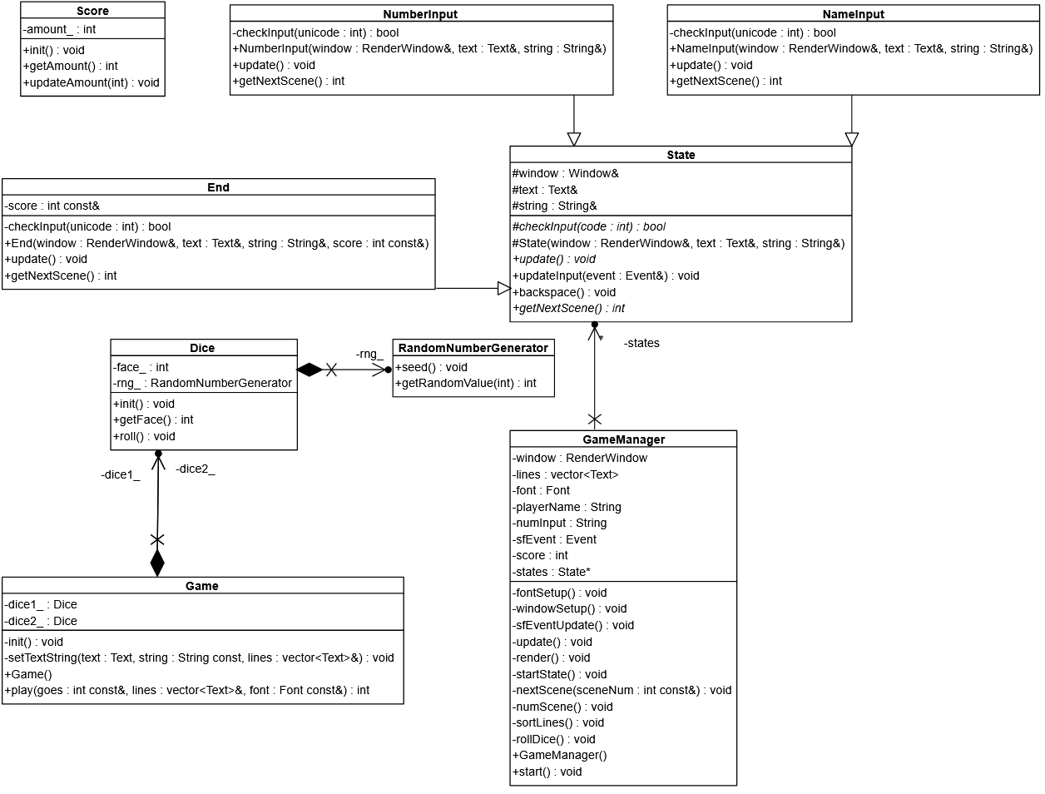

Test Plan
Expected | Actual
Player enters their name and presses enter to begin | Ok
Player enters number and presses enter for game to roll that amount of dice | OK
Player presses esc to exit the game | OK

Git commit log
